Introduction to the European Union Course
Jean Monnet Module program
15th – 20th July 2024

Program Overview
The Introduction to the European Union course will be held from July 15th – 20th, 2024 in Zagreb, Croatia. In this period, we invite you to take 12 hours of our Introduction to the European Union course, engage in self-study process, actively debate on the topics of the European Union but also join us for a company visit and a cultural event.

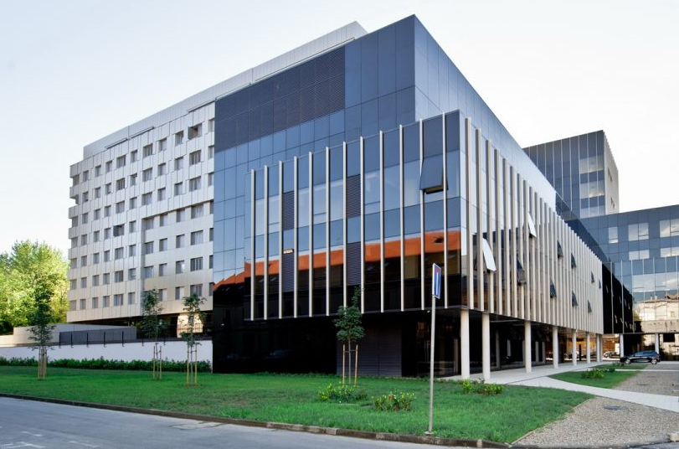
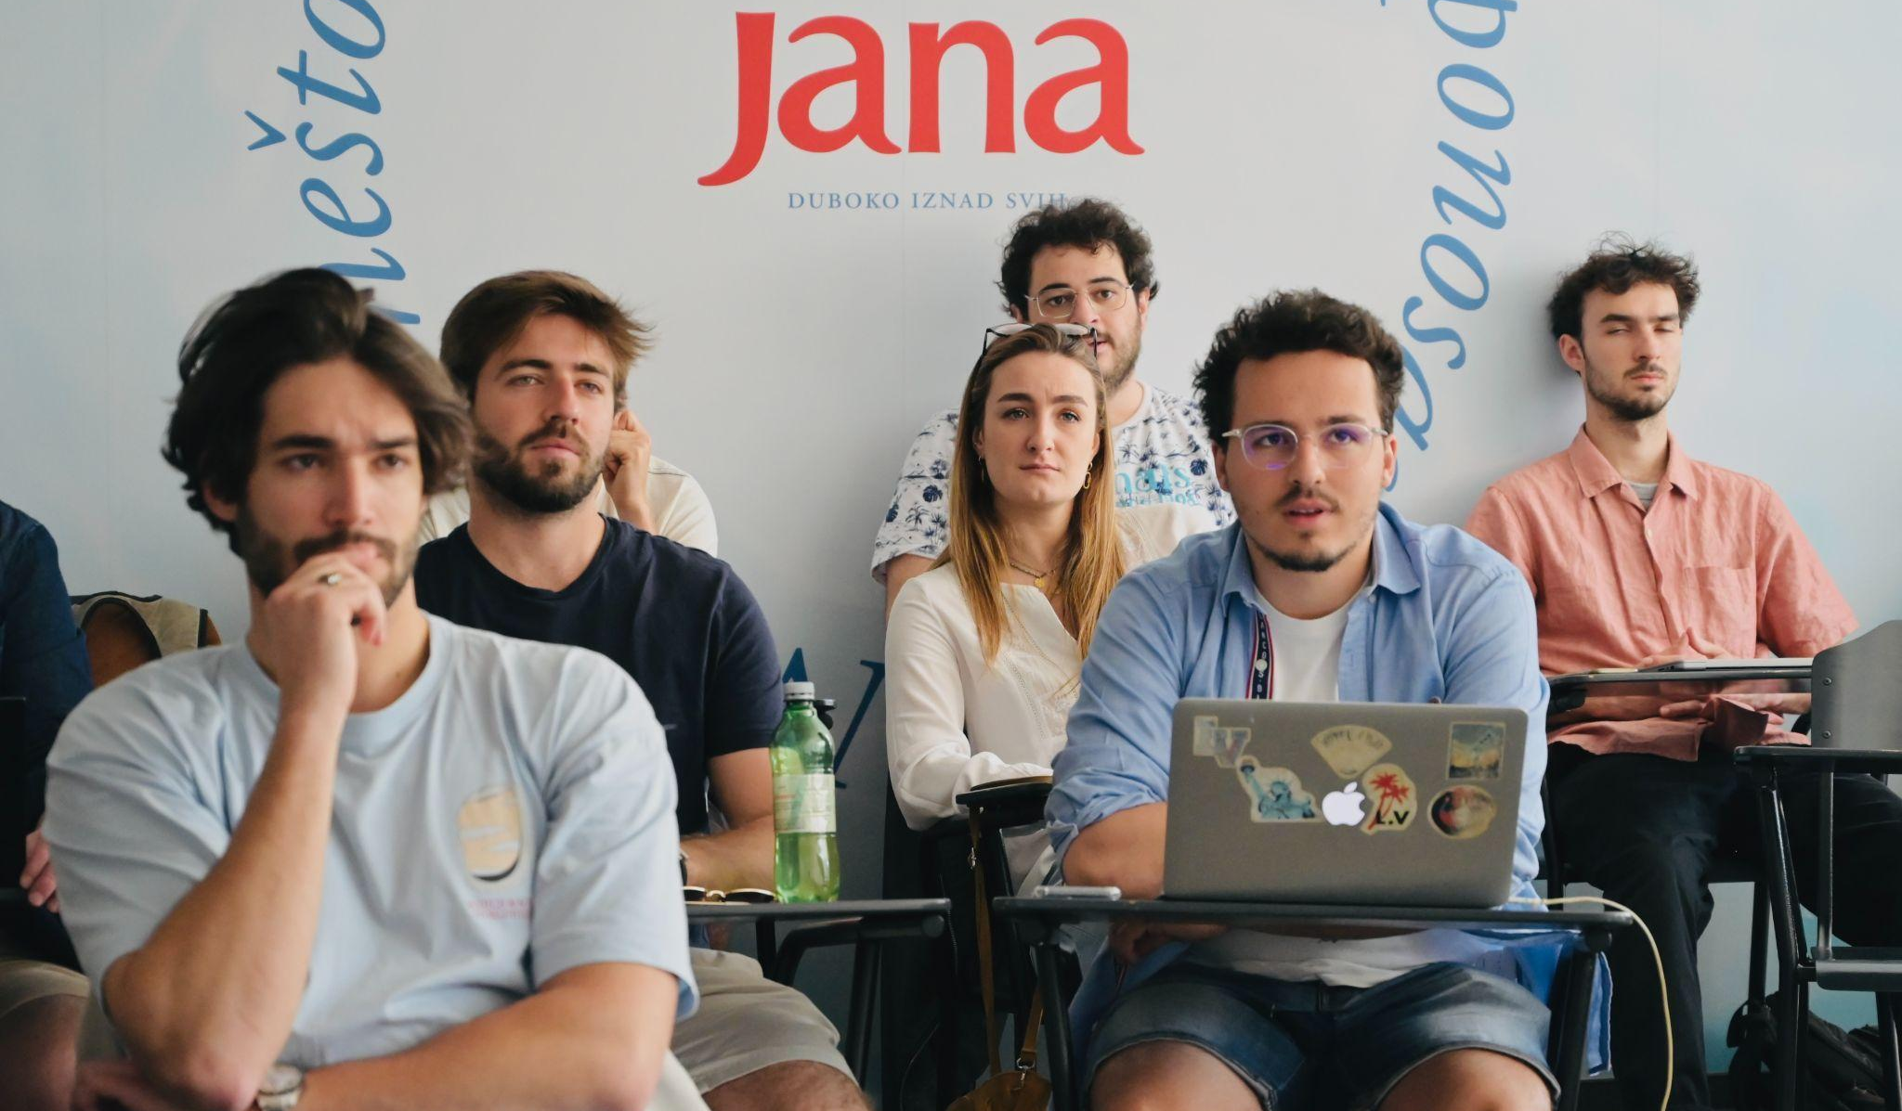

About ZSEM
The Zagreb School of Economics and Management (www.zsem.hr/en/) is Croatia’s top business school and the first Croatian higher education institution accredited by the prestigious AACSB. Its MBA programs have been ranked among the best 200 in the world by QS rankings and it received EdUniversal’s 4 Palms of Excellence. ZSEM’s strong focus on entrepreneurship coupled with excellence in education recently culminated in a huge international success: the Erasmus Mundus Master in Impact Entrepreneurship (EMMIE) – jointly delivered by ZSEM, HEC Liege (Belgium) and ISM University (Lithuania), was recently awarded the highly-coveted Erasmus Mundus status.
Additionally, ZSEM takes great pride in promoting the European Union values though our integrated EU topics but also as holders of the prestigious Jean Monnet Module titled ORPHEUS – Organisation, Preparation and Hosting EU Studies. Hereby, ZSEM represents a supporting pillar in the process of revising the European common values whilst encouraging active European citizenship as well as strengthening the role of the EU in a globalized world and raising awareness of the EU integration policy.
About Croatia
With a long and beautiful coastline flanked by more than a thousand islands, Croatia is a true Mediterranean gem. When speaking about the beautiful country of Croatia startups may not be the first thing that springs to mind. Indeed, the country is most popular as a tourist destination, but Croatia's entrepreneurs have not been quiet: Unicorns like the leading global communication platform, Infobip, or the future of mobility, Rimac – Buggati, are significant local hero businesses, and the region can boast of high-quality talent in the tech, automotive, manufacturing, and agtech spaces. Meet people from these industries, learn from the leaders of this vibrant tech ecosystem, and get to know Croatia.

Introduction to the European Union course:
- 15th – 20th July 2024
- 12 contact hours + self-study
- Topics: history, enlargement, accession and Croatia, EU institutions, the common market, 4 freedoms, economic and monetary union, harmonization, competition, EU budget and financing

Tentative Agenda:
Date/time | 15th July | 16th July | 17th July | 18th July | 19th July | 20th July | 21st July
09:00-12:00 | Introduction to the EU | Introduction to the EU | Introduction to the EU | Introduction to the EU | Revision / exam | Possibility to explore other parts of Croatia /  Return home
Afternoon / evening | Welcome dinner | Courtyards of Zagreb (‘Dvorišta’ summer event) | Visit to Rimac – Bugatti (company visit) | ‘Servus My Fair Zagreb’ (storytelling tour) | Farewell lunch/ dinner

Included in the Program – FREE OF CHARGE:
  - Course Introduction to the European Union
  - Company Visit
  - Cultural and social events

Not included in the Program:
  - Food
  - Transportation in Zagreb
  - Accommodation in Zagreb

To reserve your spot (limited number of students) please click on the LINK
Course delivery: Tomislav Sokol, PhD.
Tomislav Sokol graduated magna cum laude from the Faculty of Law of the University of Zagreb in 2006. He earned his Master’s degree at Katholieke Universiteit Leuven, Belgium’s largest university and one of the world’s top 100 universities according to Times Higher Education. His principal subjects included European Economic Law, European Constitutional Law, European and International Social Law, and European Commercial Law. In 2010 he completed the Regional Summer School on Social Security Coordination (magna cum laude) held by the Council of Europe. Tomislav Sokol has completed his Ph.D. at Katholieke Universiteit Leuven in 2014.
Tomislav Sokol is a current member of the European Parliament (Group of the European People’s Party). He is a member of the Committee on the Internal Market and Consumer Protection and member of the Subcommittee on Public Health as well as a member of the Delegation to the EU-Turkey Joint Parliamentary Committee. He also stands as a substitute member of Committee on the Environment, Public Health and Food Safety, and a substitute member of Committee on Regional Development. Additionally, prof. Sokol is a substitute member of the Delegation to the EU-Montenegro Stabilisation and Association Parliamentary Committee and a substitute member of the Delegation to the Parliamentary Assembly of the Union for the Mediterranean. He is a former member of Special Committee on Beating Cancer. He is active as the member of European Association of Health Law and European Institute of Social Security, and participates on the project Jean Monnet Network in Health Law and Policy. Tomislav Sokol is a former member of the Croatian Parliament, and prior to that, assistant minister in the Croatia Ministry of Science and Education. He gained his teaching experience as Assistant at the Law Department at ZSEM since 2007, and as a Head of the Law Department since 2014. In 2021 he has been appointed for a position of professor at ZSEM. In scientific research prof. Sokol is strongly focused on EU studies covering topics such as social citizenship, EU patient mobility, health care, and others.

Students’ Access:
Students will receive access to Moodle (ZSEM’s e-learning platform), WiFi, e-library, study room, cafeteria.

Student obligations:
Students are obligated to regularly prepare for and attend classes and actively participate in classroom discussions.

Accommodation:
We recommend renting an apartment through our partner housing agencies, although students are free to find their own accommodation through other agencies as well:
www.homeinzagreb.com www.grabahome.com

Estimated Costs of Living:
Accommodation - 100 - 350 EUR
Food - 100 EUR
City transportation - 20 EUR
Airport pick-up /drop-off (private shuttle) - 25 EUR

Other Information:
All students are required to have health and travel insurance from their home country prior to their arrival in Croatia. This type of insurance has to be valid in case any health services will need to be used while staying in Croatia.

Any questions and support that students may need prior to arriving and during their stay can be directed to the program coordinator.
